Retina

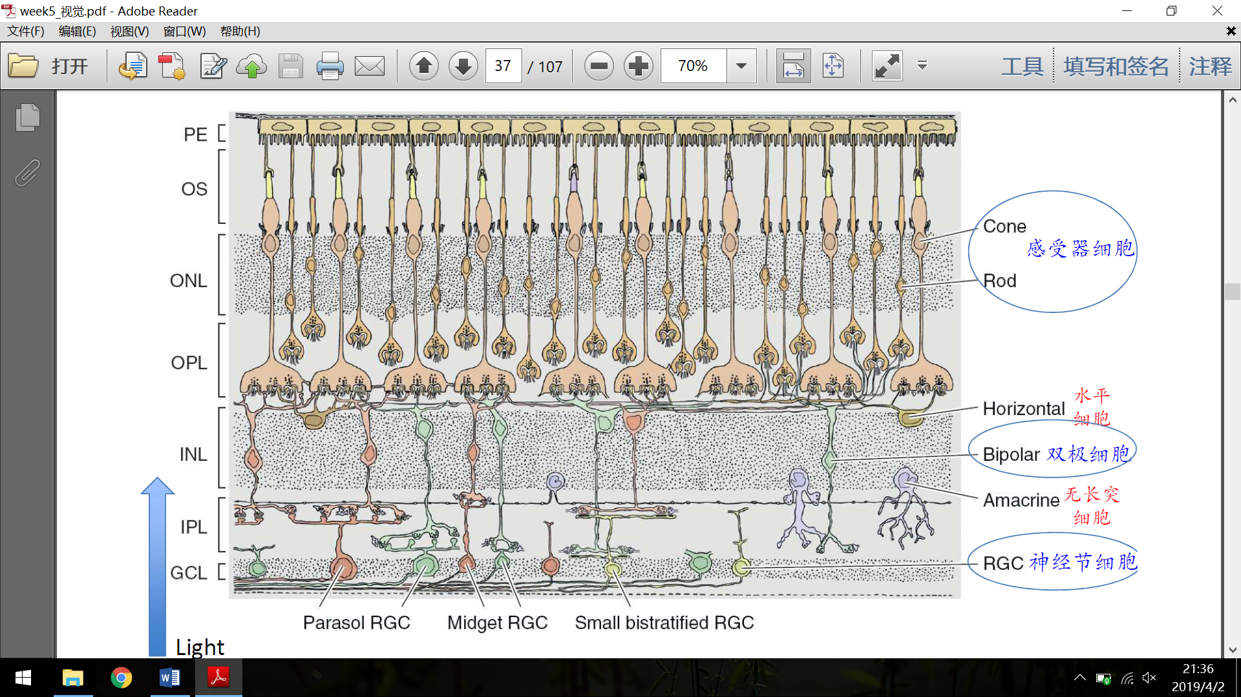

(From inner to outer layers) rods and cones, (horizontal cells), bipolar cells, (Amacrine cells), Retinal Ganglion Cells (RGC).

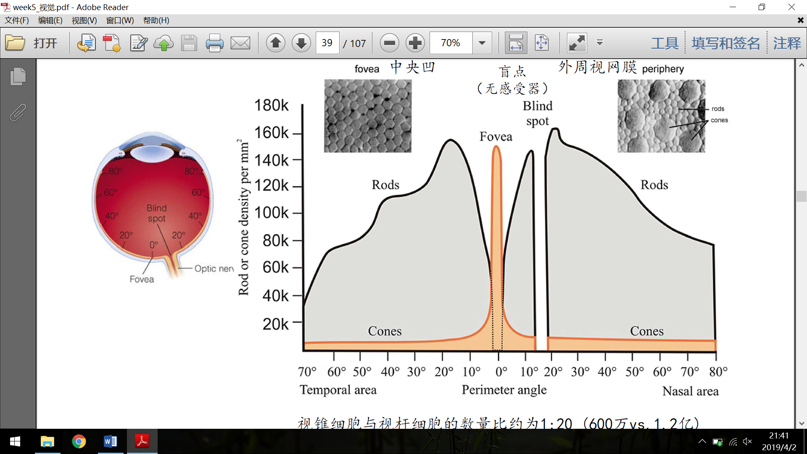

Most cones (color detectors) concentrate in the fovea area. Blind spot is at the nasal side, about 15-20 degree.

Rods and Cones

Rods are most sensitive to the light of about 500nm (only black-grey-white). Cones are tripartite (for normal people), namely S (blue), M (yellow) and L (red), at a ratio of about 1:5:10.

The difference in their sensitivity is due to the difference in visual pigments. Besides, the ones in cones are decomposed by high level of light but can be reproduced quickly, thus suitable for daylight; while the one in rods can be decomposed by weak light but needs more time to recover, thus suitable for night vision (the process of switching from cone-dominated vision to rod-dominated one is the substance of dark adaptation). The decomposition of visual pigments change the membrane potential of the downstream neurons, not by neural firing.

Bipolar cells

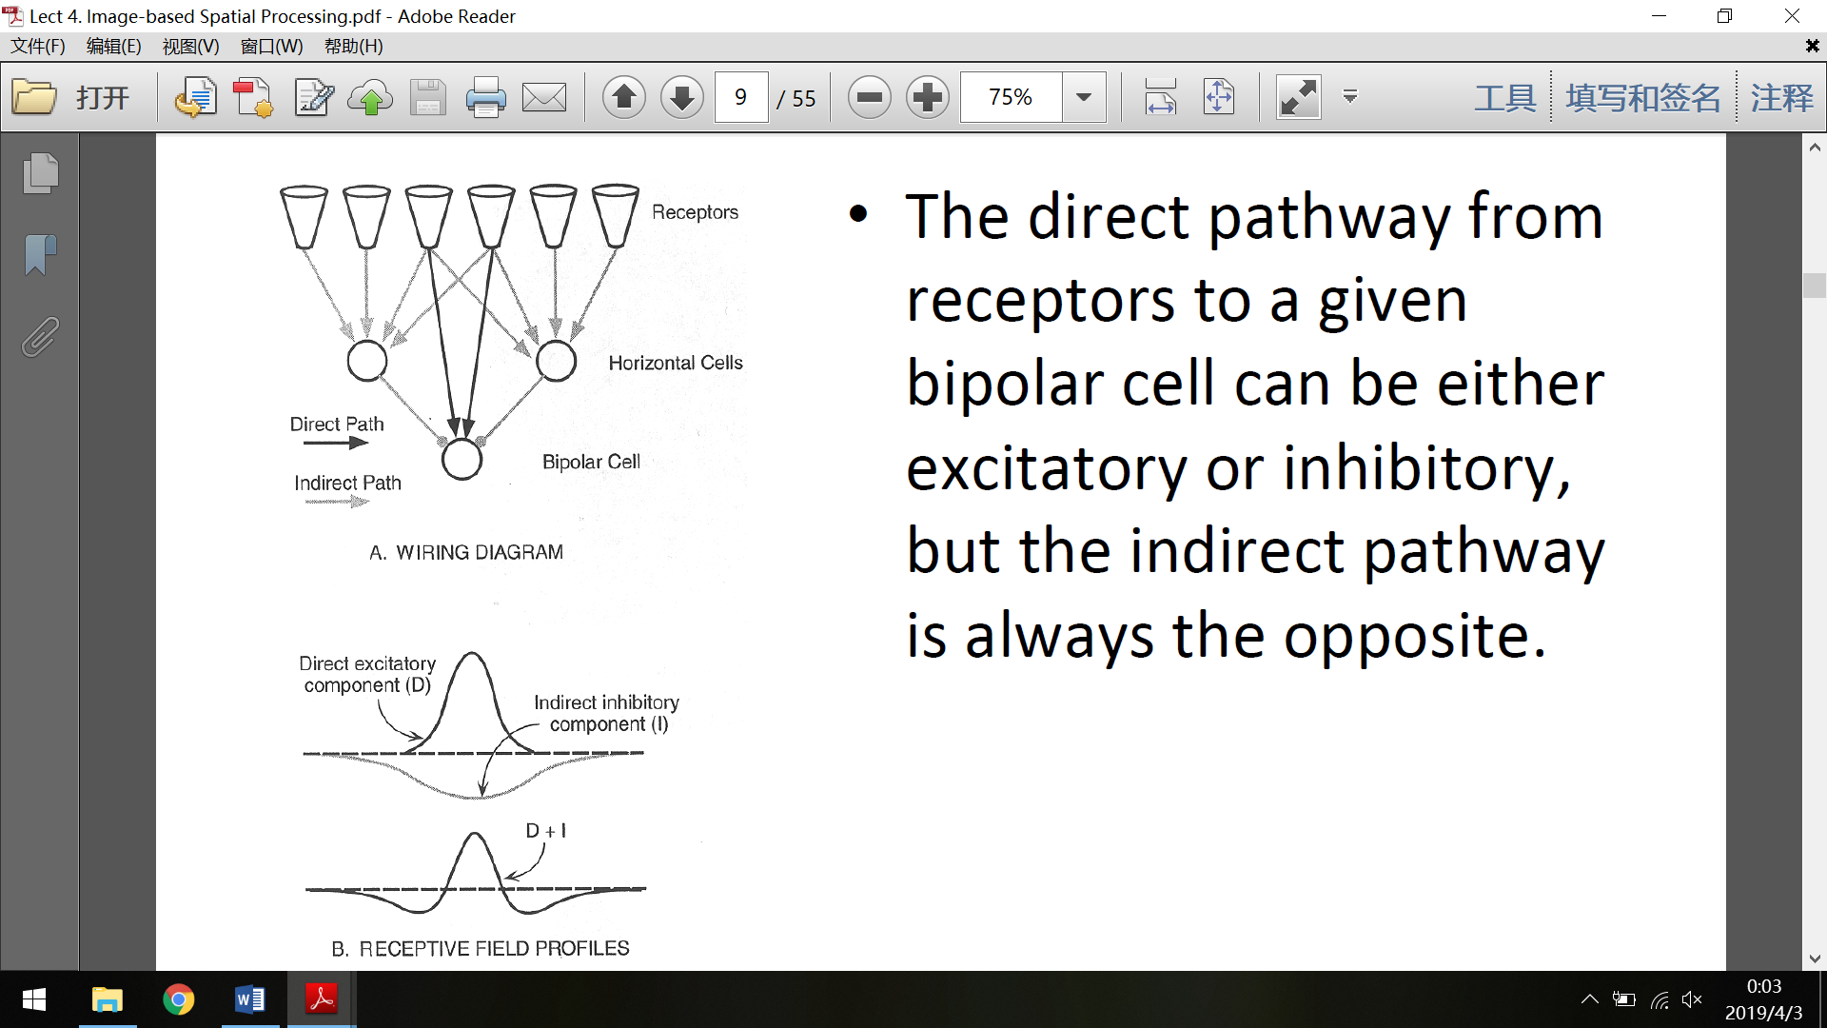

Bipolar cells receive input directly from rods and cones or through horizontal cells. They also transmit information by potential gradient and not spikes. They have similar ON-OFF receptive field like RGCs, which can possibly be explained by the model above, with the impact of horizontal cells.

Horizontal cells and Amacrine cells

They can perform lateral inhibtion, which is the cause of some phenomenon like the Mach Band. Lateral inhibition is important for making the edges more clear and distinct.

Ganglion cells

Mainly three types: M, P and K. They have center-surround antagonism and can generate spikes.

M RGCs are larger ganglion neurons with larger receptive field, poorer spatial resolution, ability to deal with motion but not color, and will be connected to the M layer of the LGN.

P RGCs are smaller ones with smaller RF with better resolution and color vision, and will be connected to the P layer of LGN.

K RGCs are moderate ones with a blue ON-centered and Yellow OFF-surround receptive field, and will be connected to the interlayer of LGN.

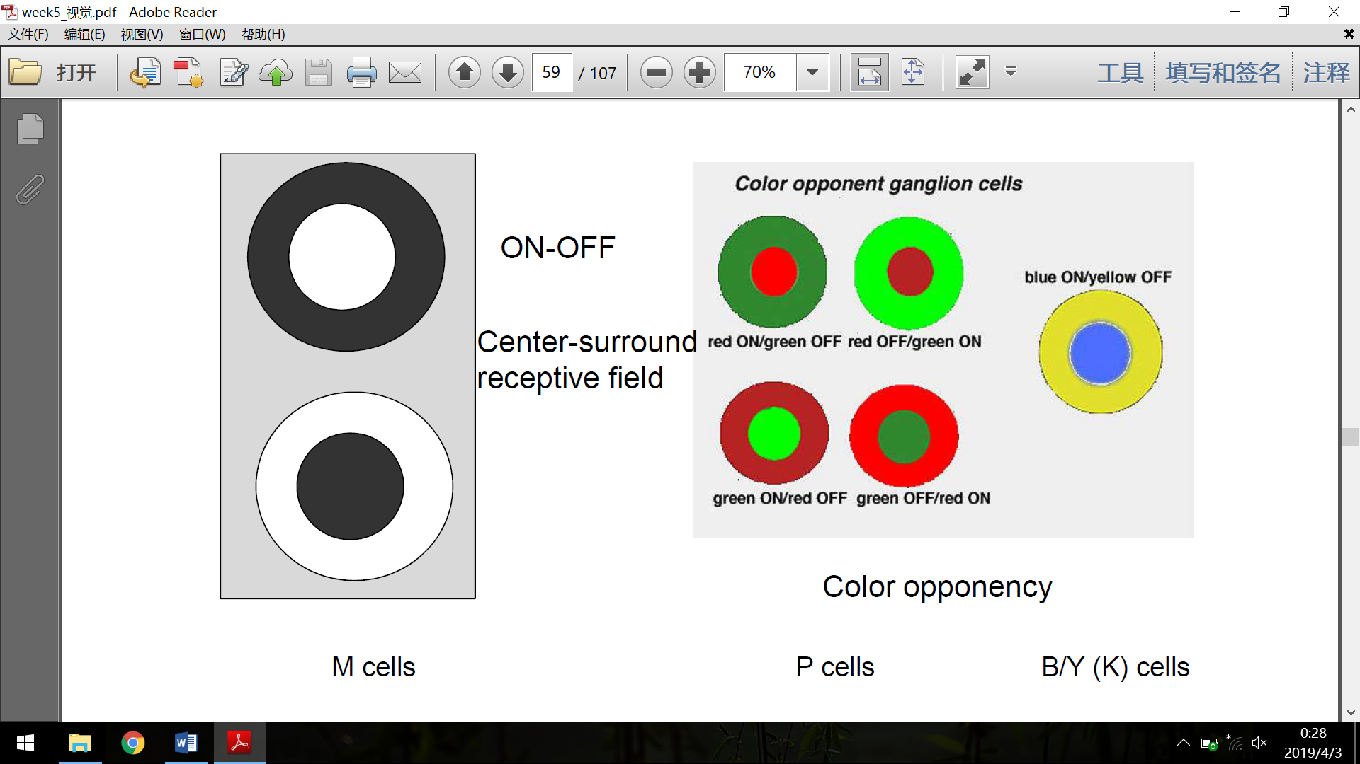

It has been supposed that some ganglion cells are color-opponent cells, such as green-red, blue-yellow and black-white (vice versa), with on-off or off-on concentric structure. But this theory is still under compute.

Optic nerve

10% of the retinal output goes through the subcortical pathway, mainly ending in the superior colliculus in midbrain, which is involved in saccade control. The other 90% goes through the cortical pathway to the striate cortex via the lateral geniculate nucleus (LGN) in the thalamus. The optic nerve from the nasal side of the retina will go through the optic chiasm, so all the information from a visual field (not an eye) will go to the contralateral hemisphere.

LGN

LGN contains six layers of neurons. Each of these layers receive input from only one eye and one kind of ganglion cells, and has a retinotopic map of its input area. Input of each layer goes like this (inside-out): contralateral M RGC, ipsilateral M RGC, ipsilateral P RGC, contralateral P RGC, ipsilateral P RGC, contralateral P RGC. And the interlayers just ventral to the numbered layers receive input from the K RGC. However, that’s only 10% of the input of LGN, while the other 90% is from cortical area or brainstem, which may be involved in attentional modulation of vision.

LGN neurons also have a receptive field of ON-OFF or OFF-ON concentric antagonistic structure, but much larger and stronger than those of RGCs.

Almost all output of LGN goes to V1 (striate cortex).

Primary Visual Cortex

Anatomical structure

Brodmann area 17, is a new cortical area which contains six layers of neurons. Layer 5 & 6 mainly contains excitatory neurons which provide feedback to LGN. Layer 4 is devided into three sublayers, and LGN M cells project to the layer 4Cα, P cells to the layer 4Cβ. Layer 2 and 3 contains excitatory neurons which project to extrastriate cortex. Layer 1 (the most superficial one) is almost aneuronal, containing dendritic and axonal connections. There are some “blob” areas in these three layers, which are actually cylindrical structures, receiving input from layer 4Cβ and LGN K cells and are sensitive to color (in V2, these areas are more like stripes).

Receptive field

Acoording to the difference in the structure of receptive field, V1 neurons can be categorized into simple cells, complex cells and hypercomplex cells. A simple cell is like a line (or edge) detector, whose receptive field can be estimated by a Garbo function, so it also has an orientation tuning. A complex cell is motion-sensitive. And a hypercomplex cell is (in addition to the complex cells’ feature) length-sensitive, which can serve as an end detector.

It’s suggested that the different receptive fields can be explained by such a model:

 



Functional column theory

Research reveals that the adjacent neurons (in one dimension) in V1 generally has similar preferred orientation, (in the other dimension) similar preferred object size (or spatial frequency, more exactly); the adjacent stripes in V1 have different dominant input (left or right eye); and that the six layers of neurons in a column structure (from inside to cortex) has developmental connections. So it’s suggested that the primary visual cortex is organized by the functional columns below (but research on monkeys shows that the orientation sensitive area may be organized into a pinwheel-like structure instead). The blobs, as mentioned before, are involved in process of color.

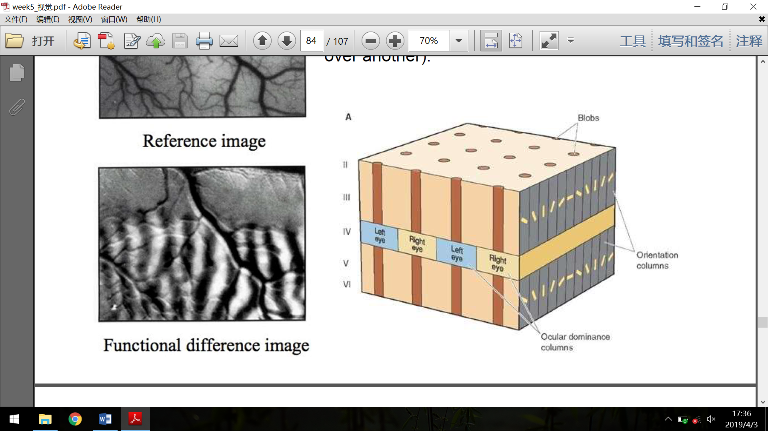 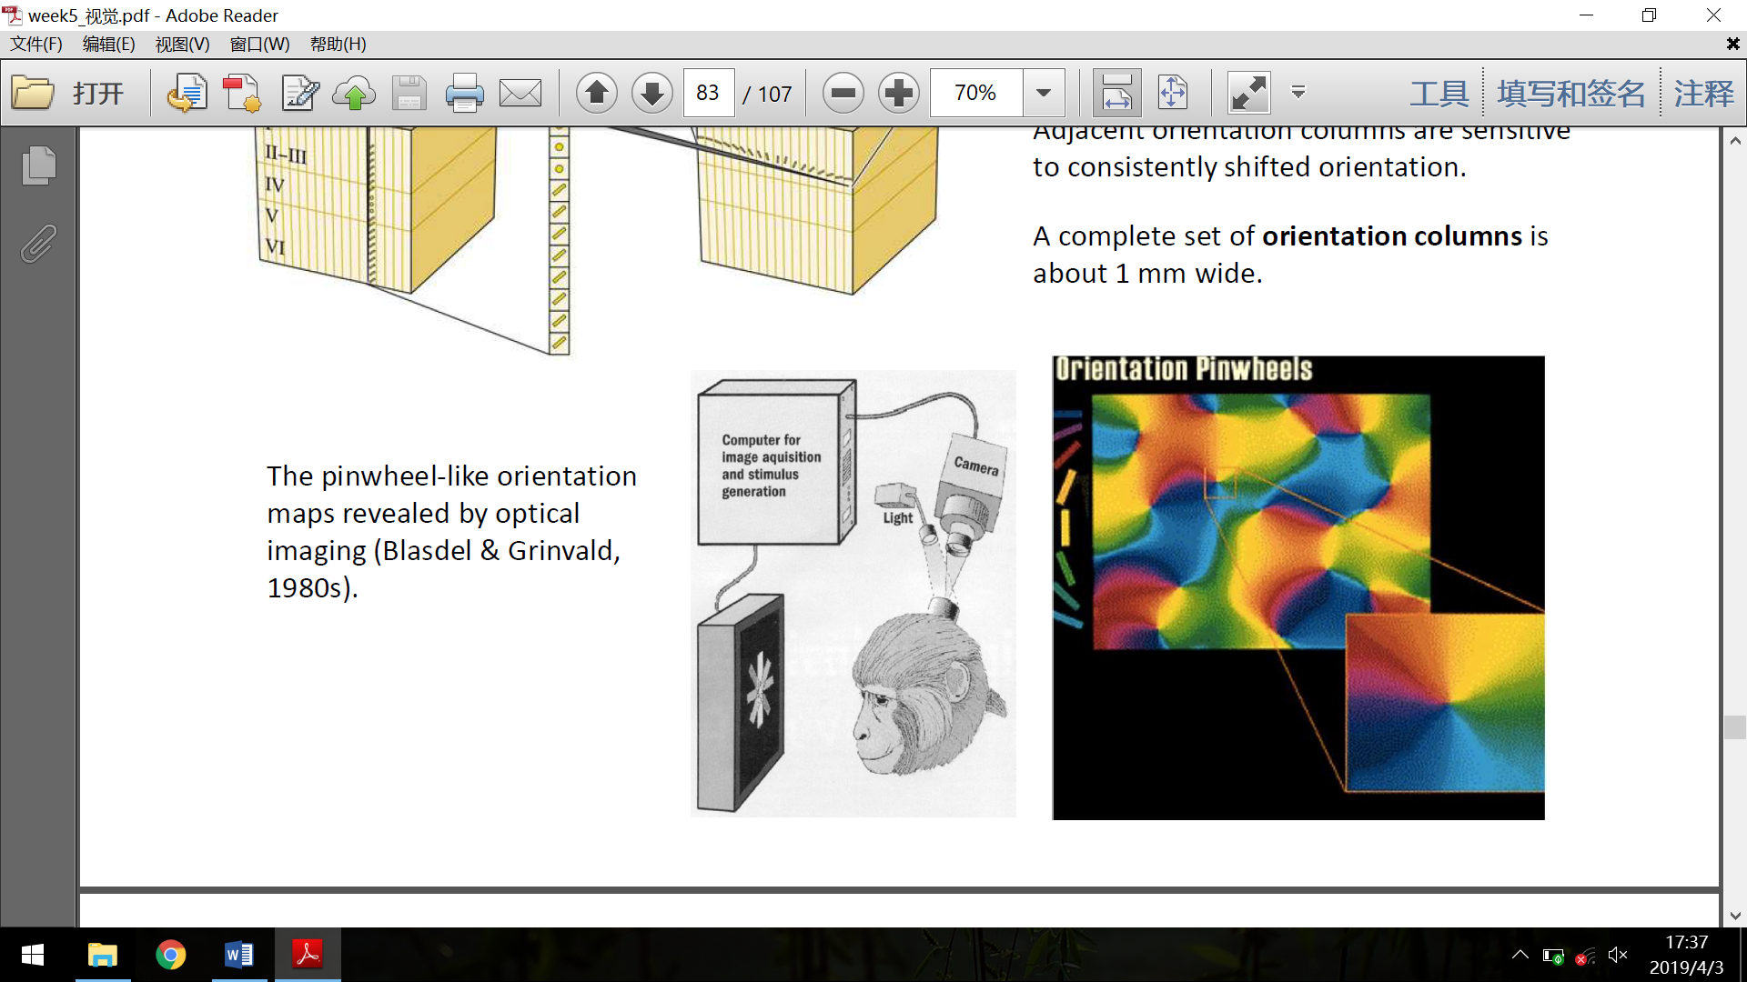

Retinotopic map

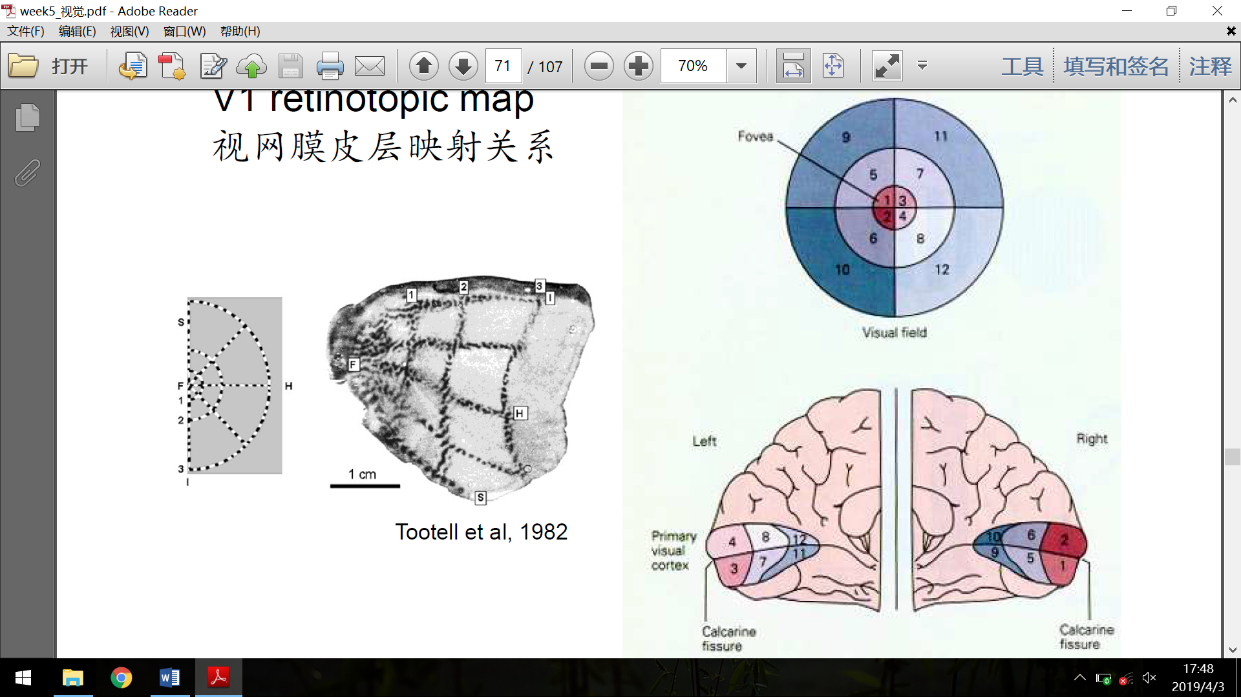

The topography of visual field is maintained through the early process of vision. One interesting phenomenon is called the cortical magnification, which means that small areas around the fovea is represented by a very large area in V1, leading to better visual sensitivity.

Two pathway

Output of V1 will generally go through two pathways, the dorsal one (including V2, V3, MT (V5), MST, LIP and so on) and the ventral one (including V4, IT and so on). The former (“where” pathway) is believed to be closely connected with spatial recognition and motion, while the other (“what” pathway) is more relevant to color/detail process and object recognition.

